Operations Management, 10e, Global Edition (Heizer/Render)
Chapter 6 Supplement Statistical Process Control

1) Some degree of variability is present in almost all processes.
Answer: TRUE
Diff: 1
Topic: Statistical Process Control (SPC)
Objective: no LO

2) The purpose of process control is to detect when natural causes of variation are present.
Answer: FALSE
Diff: 2
Topic: Statistical Process Control (SPC)
Objective: LO6-Supplement-1

3) A normal distribution is generally described by its two parameters: the mean and the range.
Answer: FALSE
Diff: 1
Topic: Statistical Process Control (SPC)
Objective: LO6-Supplement-2

4) A process is said to be in statistical control when assignable causes are the only sources of variation.
Answer: FALSE
Diff: 2
Topic: Statistical Process Control (SPC)
Objective: LO6-Supplement-2

5) Mistakes stemming from workers' inadequate training represent an assignable cause of variation.
Answer: TRUE
Diff: 1
Topic: Statistical Process Control (SPC)
Objective: LO6-Supplement-1

6) Averages of small samples, not individual measurements, are generally used in statistical process control.
Answer: TRUE
Diff: 2
Topic: Statistical Process Control (SPC)
Objective: LO6-Supplement-2

7) The x-bar chart indicates that a gain or loss of uniformity has occurred in dispersion of a production process.
Answer: FALSE
Diff: 2
Topic: Statistical Process Control (SPC)
Objective: LO6-Supplement-3
8) The Central Limit Theorem states that when the sample size increases, the distribution of the sample means will approach the normal distribution.
Answer: TRUE
Diff: 2
Topic: Statistical Process Control (SPC)
Objective: LO6-Supplement-2

9) In statistical process control, the range often substitutes for the standard deviation.
Answer: TRUE
Diff: 2
Topic: Statistical Process Control (SPC)
Objective: LO6-Supplement-2

10) If the process average is in control, then the process range must also be in control.
Answer: FALSE
Diff: 2
Topic: Statistical Process Control (SPC)
Objective: LO6-Supplement-1

11) A process range chart illustrates the amount of variation within the samples.
Answer: TRUE
Diff: 2
Topic: Statistical Process Control (SPC)
Objective: LO6-Supplement-1

12) Mean charts and range charts complement one another, one detecting shifts in process average, the other detecting shifts in process dispersion.
Answer: TRUE
Diff: 2
Topic: Statistical Process Control (SPC)
Objective: LO6-Supplement-1

13) X-bar charts are used when we are sampling attributes.
Answer: FALSE
Diff: 1
Topic: Statistical Process Control (SPC)
Objective: LO6-Supplement-3

14) To measure the voltage of batteries, one would sample by attributes.
Answer: FALSE
Diff: 1
Topic: Statistical Process Control (SPC)
Objective: LO6-Supplement-4

15) A p-chart is appropriate to plot the number of typographic errors per page of text.
Answer: FALSE
Diff: 1
Topic: Statistical Process Control (SPC)
Objective: LO6-Supplement-5
16) A c-chart is appropriate to plot the number of flaws in a bolt of fabric.
Answer: TRUE
Diff: 1
Topic: Statistical Process Control (SPC)
Objective: LO6-Supplement-5

17) The x-bar chart, like the c-chart, is based on the exponential distribution.
Answer: FALSE
Diff: 2
Topic: Statistical Process Control (SPC)
Objective: LO6-Supplement-3

18) A process that is in statistical control will always yield products that meet their design specifications.
Answer: FALSE
Diff: 2
Topic: Process capability
Objective: LO6-Supplement-6

19) The higher the process capability ratio, the greater the likelihood that process will be within design specifications.
Answer: TRUE
Diff: 2
Topic: Process capability
Objective: LO6-Supplement-6

20) The Cpk index measures the difference between desired and actual dimensions of goods or services produced.
Answer: TRUE
Diff: 2
Topic: Process capability
Objective: LO6-Supplement-6

21) Acceptance sampling accepts or rejects an entire lot based on the information contained in the sample.
Answer: TRUE
Diff: 2
Topic: Acceptance sampling
Objective: LO6-Supplement-7

22) A lot that is accepted by acceptance sampling is free of defects.
Answer: FALSE
Diff: 2
Topic: Acceptance sampling
Objective: LO6-Supplement-7
23) In acceptance sampling, a manager can reach the wrong conclusion if the sample is not representative of the population it was drawn from.
Answer: TRUE
Diff: 2
Topic: Acceptance sampling
Objective: LO6-Supplement-7

24) The probability of rejecting a good lot is known as consumer's risk.
Answer: FALSE
Diff: 2
Topic: Acceptance sampling
Objective: LO6-Supplement-7

25) An acceptance sampling plan must define "good lots" and "bad lots" and specify the risk level associated with each one.
Answer: TRUE
Diff: 2
Topic: Acceptance sampling
Objective: LO6-Supplement-7

26) The acceptable quality level (AQL) is the average level of quality we are willing to accept.
Answer: FALSE
Diff: 2
Topic: Acceptance sampling
Objective: LO6-Supplement-7

27) The steeper an OC curve, the better it discriminates between good and bad lots.
Answer: TRUE
Diff: 2
Topic: Acceptance sampling
Objective: LO6-Supplement-7

28) If a sample of items is taken and the mean of the sample is outside the control limits the process is
A) out of control and the cause should be established
B) in control, but not capable of producing within the established control limits
C) within the established control limits with only natural causes of variation
D) monitored closely to see if the next sample mean will also fall outside the control limits
E) producing high quality products
Answer: A
Diff: 2
Topic: Statistical Process Control (SPC)
Objective: LO6-Supplement-1
29) The causes of variation in statistical process control are
A) cycles, trends, seasonality, and random variations
B) producer's causes and consumer's causes
C) mean and range
D) natural causes and assignable causes
E) Type I and Type II
Answer: D
Diff: 2
Topic: Statistical Process Control (SPC)
Objective: LO6-Supplement-1

30) Natural variations
A) affect almost every production process
B) are the many sources of variation that occur when a process is under control
C) when grouped, form a pattern, or distribution
D) are tolerated, within limits, when a process is under control
E) All of the above are true.
Answer: E
Diff: 2
Topic: Statistical Process Control (SPC)
Objective: LO6-Supplement-1

31) Natural variations
A) are variations that are to be identified and investigated
B) are variations that can be traced to a specific cause
C) are the same as assignable variations
D) lead to occasional false findings that processes are out of control
E) play no role in statistical process control
Answer: D
Diff: 2
Topic: Statistical Process Control (SPC)
Objective: LO6-Supplement-1

32) Assignable variation
A) is a sign that a process is under control
B) is to be identified and investigated
C) is the same as random variation
D) is variation that cannot be traced to a specific cause
E) leads to a steep OC curve
Answer: B
Diff: 2
Topic: Statistical Process Control (SPC)
Objective: LO6-Supplement-1
33) Assignable causes
A) are not as important as natural causes
B) are within the limits of a control chart
C) depend on the inspector assigned to the job
D) are also referred to as "chance" causes
E) are causes of variation that can be identified and investigated
Answer: E
Diff: 2
Topic: Statistical Process Control (SPC)
Objective: LO6-Supplement-1

34) Control charts for variables are based on data that come from
A) acceptance sampling
B) individual items
C) averages of small samples
D) averages of large samples
E) the entire lot
Answer: C
Diff: 2
Topic: Statistical Process Control (SPC)
Objective: LO6-Supplement-1

35) The purpose of an x-bar chart is to determine whether there has been a
A) gain or loss in uniformity
B) change in the percent defective in a sample
C) change in the central tendency of the process output
D) change in the number of defects in a sample
E) change in the AOQ
Answer: C
Diff: 2
Topic: Statistical Process Control (SPC)
Objective: LO6-Supplement-2

36) The number of defects after a hotel room cleaning (sheets not straight, smears on mirror, missed debris on carpet, etc) should be measured using a(n)
A) x-bar chart
B) R-chart
C) p-chart
D) c-chart
E) either x-bar or R chart
Answer: D
Diff: 2
Topic: Statistical Process Control (SPC)
Objective: LO6-Supplement-5
37) The number of late insurance claim payouts per 100 should be measured with a
A) x-bar chart
B) R-chart
C) p-chart
D) c-chart
E) either a p or c chart
Answer: C
Diff: 2
Topic: Statistical Process Control (SPC)
Objective: LO6-Supplement-5

38) The upper and lower limits for diving ring diameters made by John's Swimming are 40 and 39 cm. John took 11 samples with the following average diameters (39, 39.1, 39.2, 39.3, 39.4, 39.5 39.6, 39.7, 39.8, 39.9, 40). Is the process in control?
A) Yes, no diameters exceeded the control limits.
B) No, some diameters exceeded the control limits.
C) No, there is a distinguishable pattern to the samples.
D) No, the range is not in control.
E) There is not enough information to make a decision.
Answer: C
Diff: 2
Topic: Statistical Process Control (SPC)
AACSB: Analytic Skills
Objective: LO6-Supplement-3

39) Red Top Cab Company receives multiple complaints per day about driver behavior. Over 9 days the owner recorded the number of calls to be 3, 0, 8, 9, 6, 7, 4, 9, 8. What is the lower control limit for x-bar?
A) 0
B) -1.35
C) -2
D) 1.35
E) none of the above
Answer: A
Diff: 2
Topic: Statistical Process Control (SPC)
AACSB: Analytic Skills
Objective: LO6-Supplement-5
40) A process that is assumed to be in control with limits of 89 +/- 2 had sample averages of the following- 87.1, 87, 87.2, 89, 90, 89.5, 88.5, and 88. Is the process in control?
A) Yes
B) No, one or more averages exceeded the limits.
C) Not enough information to tell.
D) No, there is a distinguishable trend.
E) No, two or more consecutive points are very near the lower (or upper) limit.
Answer: E
Diff: 2
Topic: Statistical Process Control (SPC)
AACSB: Analytic Skills
Objective: LO6-Supplement-3

41) Ten samples of a process measuring the number of returns per 100 receipts were taken for a local retail store. The number of returns were 10, 9, 11, 7, 3, 12, 8, 4, 6, 11. Find the standard deviation of the sampling distribution. (Hint- Use p-bar formula)
A) There is not enough information
B) .081
C) 8.1
D) .0273
E) .0863
Answer: E
Diff: 2
Topic: Statistical Process Control (SPC)
AACSB: Analytic Skills
Objective: LO6-Supplement-5

42) An x-bar control chart was examined and no data points fell outside of the limits. Can this process be considered in control?
A) No, there could be a pattern to the points.
B) No, the R-chart must be checked.
C) No, the number of samples must be known.
D) Yes
E) Both A and B
Answer: E
Diff: 2
Topic: Statistical Process Control (SPC)
Objective: LO6-Supplement-3
43) Statistical process control charts
A) display the measurements on every item being produced
B) display upper and lower limits for process variables or attributes, and signal when a process is no longer in control
C) indicate to the process operator the average outgoing quality of each lot
D) indicate to the operator the true quality of material leaving the process
E) none of the above
Answer: B
Diff: 2
Topic: Statistical Process Control (SPC)
Objective: LO6-Supplement-1

44) A sample of parts is measured. The mean of this sample is in the middle of the control limits, but some individual parts measure too low for design specifications and other parts measure too high. Which of the following is true?
A) The process is out of control, and the cause should be established.
B) The process is in control, but not capable of producing within the established control limits.
C) The process is within the established control limits with only natural causes of variation.
D) The process is outside the established control limits with only natural causes of variation.
E) The process is in control, and there is nothing to worry about.
Answer: B
Diff: 3
Topic: Statistical Process Control (SPC)
Objective: LO6-Supplement-1

45) The Central Limit Theorem
A) is the theoretical foundation of the c-chart
B) states that the average of assignable variations is zero
C) allows managers to use the normal distribution as the basis for building some control charts
D) states that the average range can be used as a proxy for the standard deviation
E) controls the steepness of an operating characteristic curve
Answer: C
Diff: 3
Topic: Statistical Process Control (SPC)
Objective: LO6-Supplement-2

46) For an x-bar chart where the standard deviation is known, the Upper Control Limit
A) is 3 . σ below the mean of sample means for a 3σ control chart
B) is 3 . σ above the mean of sample means for a 3σ control chart
C) is 3 . σ/ below the mean of sample means for a 3σ control chart
D) is 3 . σ/ above the mean of sample means for a 3σ control chart
E) Cannot be calculated unless the average range is known.
Answer: D
Diff: 2
Topic: Statistical Process Control (SPC)
Objective: LO6-Supplement-3
47) Up to three standard deviations above or below the centerline is the amount of variation that statistical process control allows for
A) Type I errors
B) about 95.5% variation
C) natural variation
D) all types of variation
E) assignable variation
Answer: C
Diff: 2
Topic: Statistical Process Control (SPC)
Objective: LO6-Supplement-1

48) A manager wants to build control limits for a process. The target value for the mean of the process is 10 units, and the standard deviation of the process is 6. If samples of size 9 are to be taken, the UCL and LCL will be
A) -8 and 28
B) 16 and 4
C) 12 and 8
D) 4 and 16
E) 8 and 12
Answer: B
Diff: 2
Topic: Statistical Process Control (SPC)
AACSB: Analytic Skills
Objective: LO6-Supplement-3

49) The type of inspection that classifies items as being either good or defective is
A) variable inspection
B) attribute inspection
C) fixed inspection
D) all of the above
E) none of the above
Answer: B
Diff: 2
Topic: Statistical Process Control (SPC)
Objective: LO6-Supplement-7

50) The x-bar chart tells us whether there has been a
A) gain or loss in dispersion
B) change in the percent defective in a sample
C) change in the central tendency of the process output
D) change in the number of defects in a sample
E) none of the above
Answer: C
Diff: 2
Topic: Statistical Process Control (SPC)
Objective: LO6-Supplement-3
51) The mean and standard deviation for a process for which we have a substantial history are µ = 120 and σ = 2. For the variable control chart, a sample size of 16 will be used. What is the mean of the sampling distribution?
A) 1/8 (0.125)
B) 0.5
C) 2
D) 40
E) cannot be determined
Answer: E
Diff: 2
Topic: Statistical Process Control (SPC)
AACSB: Analytic Skills
Objective: no LO
52) Jars of pickles are sampled and weighed. Sample measures are plotted on control charts. The ideal weight should be precisely 11 oz. Which type of chart(s) would you recommend?
A) p-charts
B) c-charts
C) - and R-charts
D) -, but not R-charts
E) both p- and c-charts
Answer: C
Diff: 2
Topic: Statistical Process Control (SPC)
Objective: LO6-Supplement-3

53) If = 23 ounces, σ = 0.4 ounces, and n = 16, the ±3σ control limits will be
A) 21.8 to 24.2 ounces
B) 23 ounces
C) 22.70 to 23.30 ounces
D) 22.25 to 23.75 ounces
E) none of the above
Answer: C
Diff: 2
Topic: Statistical Process Control (SPC)
AACSB: Analytic Skills
Objective: LO6-Supplement-3

54) The usual purpose of an R-chart is to signal whether there has been a
A) gain or loss in dispersion
B) change in the percent defective in a sample
C) change in the central tendency of the process output
D) change in the number of defects in a sample
E) none of the above
Answer: A
Diff: 2
Topic: Statistical Process Control (SPC)
Objective: LO6-Supplement-3
55) A manager wishes to build a σ range chart for a process. The sample size is five, the mean of sample means is 16.01, and the average range is 5.3. From Table S6.1, the appropriate value of D3 is 0, and D4 is 2.115. The UCL and LCL for this range chart are
A) 33.9 and 11.2
B) 33.9 and 0
C) 11.2 and 0
D) 6.3 and 0
E) 31.91 and 0.11
Answer: C
Diff: 2
Topic: Statistical Process Control (SPC)
AACSB: Analytic Skills
Objective: LO6-Supplement-3

56) Plots of sample ranges indicate that the most recent value is below the lower control limit. What course of action would you recommend?
A) Since there is no obvious pattern in the measurements, variability is in control.
B) One value outside the control limits is insufficient to warrant any action.
C) Lower than expected dispersion is a desirable condition; there is no reason to investigate.
D) The process is out of control; reject the last units produced.
E) Variation is not in control; investigate what created this condition.
Answer: E
Diff: 3
Topic: Statistical Process Control (SPC)
Objective: LO6-Supplement-4

57) To set -chart upper and lower control limits, one must know the process central line, which is the
A) average of the sample means
B) total number of defects in the population
C) percent defects in the population
D) size of the population
E) average range
Answer: A
Diff: 2
Topic: Statistical Process Control (SPC)
Objective: LO6-Supplement-3

58) According to the text, the most common choice of limits for control charts is usually
A) ± 1 standard deviation
B) ± 2 standard deviations
C) ± 3 standard deviations
D) ± 3 standard deviations for means and ± 2 standard deviations for ranges
E) none of the above
Answer: C
Diff: 2
Topic: Statistical Process Control (SPC)
Objective: LO6-Supplement-1
59) Which of the following is true of a p-chart?
A) The lower control limit is found by subtracting a fraction from the average number of defects.
B) The lower control limit indicates the minimum acceptable number of defects.
C) The lower control limit may be below zero.
D) The lower control limit may be at zero.
E) The lower control limit is the same as the lot tolerance percent defective.
Answer: D
Diff: 2
Topic: Statistical Process Control (SPC)
Objective: LO6-Supplement-5

60) The normal application of a p-chart is in
A) process sampling by variables
B) acceptance sampling by variables
C) process sampling by attributes
D) acceptance sampling by attributes
E) none of the above
Answer: C
Diff: 2
Topic: Statistical Process Control (SPC)
Objective: LO6-Supplement-5

61) The statistical process chart used to control the number of defects per unit of output is the
A) -chart
B) R-chart
C) p-chart
D) AOQ chart
E) c-chart
Answer: E
Diff: 2
Topic: Statistical Process Control (SPC)
Objective: LO6-Supplement-5

62) The c-chart signals whether there has been a
A) gain or loss in uniformity
B) change in the number of defects per unit
C) change in the central tendency of the process output
D) change in the percent defective in a sample
E) change in the AOQ
Answer: B
Diff: 2
Topic: Statistical Process Control (SPC)
Objective: LO6-Supplement-5
63) The local newspaper receives several complaints per day about typographic errors. Over a seven-day period, the publisher has received calls from readers reporting the following number of errors: 4, 3, 2, 6, 7, 3, and 9. Based on these data alone, what type of control chart(s) should the publisher use?
A) p-chart
B) c-chart
C) -chart
D) R-chart
E) - and R-charts
Answer: B
Diff: 2
Topic: Statistical Process Control (SPC)
Objective: LO6-Supplement-5

64) A manufacturer uses statistical process control to control the quality of the firm's products. Samples of 50 of Product A are taken, and a defective/acceptable decision is made on each unit sampled. For Product B, the number of flaws per unit is counted. What type(s) of control charts should be used?
A) p-charts for A and B
B) p-chart for A, c-chart for B
C) c-charts for both A and B
D) p-chart for A, mean and range charts for B
E) c-chart for A, mean and range charts for B
Answer: B
Diff: 3
Topic: Statistical Process Control (SPC)
Objective: LO6-Supplement-5

65) A nationwide parcel delivery service keeps track of the number of late deliveries (more than 30 minutes past the time promised to clients) per day. They plan on using a control chart to plot their results. Which type of control chart(s) would you recommend?
A) - and R-charts
B) p-charts
C) c-charts
D) -, but not R-charts
E) both p- and c-charts
Answer: C
Diff: 2
Topic: Statistical Process Control (SPC)
Objective: LO6-Supplement-5
66) A run test is used
A) to examine variability in acceptance sampling plans
B) in acceptance sampling to establish control
C) to examine points in a control chart to check for natural variability
D) to examine points in a control chart to check for nonrandom variability
E) none of the above
Answer: D
Diff: 2
Topic: Statistical Process Control (SPC)
Objective: LO6-Supplement-4

67) The main difference between Cp and Cpk is that
A) only one ensures the process mean is centered within the limits
B) Cp values above 1 indicate a capable process, Cpk values above 2 indicate a capable process
C) both are identical
D) Cp values for a given process will always be greater than or equal to Cpk values
E) both A and D
Answer: E
Diff: 3
Topic: Process capability
Objective: LO6-Supplement-6

68) A Cp of 1.33 indicates how many sigma limits
A) 1
B) 1.33
C) 2
D) 3
E) 4
Answer: E
Diff: 2
Topic: Process capability
Objective: LO6-Supplement-6

69) Which of the following is true regarding the process capability index Cpk?
A) A Cpk index value of 1 is ideal, meaning all units meet specifications.
B) The larger the Cpk, the more units meet specifications.
C) The Cpk index can only be used when the process centerline is also the specification centerline.
D) Positive values of the Cpk index are good; negative values are bad.
E) None of the above is true.
Answer: B
Diff: 2
Topic: Process capability
Objective: LO6-Supplement-6
70) If the Cpk index exceeds 1
A) the AQL must be smaller than the LTPD
B) σ must be less than one-third of the difference between the specification and the process mean
C) the x-bar chart must indicate that the process is in control
D) the process is capable of Six Sigma quality
E) the process is characterized as "not capable"
Answer: B
Diff: 2
Topic: Process capability
Objective: LO6-Supplement-6

71) The statistical definition of Six Sigma allows for 3.4 defects per million. This is achieved by a Cpk index of
A) 0
B) 1
C) 1.33
D) 1.67
E) 2
Answer: E
Diff: 2
Topic: Process capability
Objective: LO6-Supplement-6

72) A Cpk index of 1.00 equates to a defect rate of
A) five percent
B) 3.4 defects per million
C) 2.7 per 1,000 items
D) 97.23 percent
E) one percent
Answer: C
Diff: 2
Topic: Process capability
Objective: LO6-Supplement-6

73) Acceptance sampling
A) is the application of statistical techniques to the control of processes
B) was developed by Walter Shewhart of Bell Laboratories
C) is used to determine whether to accept or reject a lot of material based on the evaluation of a sample
D) separates the natural and assignable causes of variation
E) all of the above
Answer: C
Diff: 2
Topic: Acceptance sampling
Objective: LO6-Supplement-7
74) Acceptance sampling's primary purpose is to
A) estimate process quality
B) estimate lot quality
C) detect and eliminate defectives
D) decide if a lot meets predetermined standards
E) determine whether defective items found in sampling should be replaced
Answer: D
Diff: 3
Topic: Acceptance sampling
Objective: LO6-Supplement-7

75) An acceptance sampling plan's ability to discriminate between low quality lots and high quality lots is described by
A) a Gantt chart
B) the Central Limit Theorem
C) a process control chart
D) an operating characteristics curve
E) a range chart
Answer: D
Diff: 2
Topic: Acceptance sampling
Objective: LO6-Supplement-7

76) Acceptance sampling
A) may involve inspectors taking random samples (or batches) of finished products and measuring them against predetermined standards
B) may involve inspectors taking random samples (or batches) of incoming raw materials and measuring them against predetermined standards
C) is more economical than 100% inspection
D) may be either of a variable or attribute type, although attribute inspection is more common in the business environment
E) All of the above are true.
Answer: E
Diff: 2
Topic: Acceptance sampling
Objective: LO6-Supplement-7
77) Which of the following statements on acceptance sampling is true?
A) Acceptance sampling draws samples from a population of items, tests the sample, and accepts the entire population if the sample is good enough, and rejects it if the sample is poor enough.
B) The sampling plan contains information about the sample size to be drawn and the critical acceptance or rejection numbers for that sample size.
C) The steeper an operating characteristic curve, the better its ability to discriminate between good and bad lots.
D) All of the above are true.
E) All of the above are false.
Answer: D
Diff: 2
Topic: Acceptance sampling
Objective: LO6-Supplement-7

78) Acceptance sampling is usually used to control
A) the number of units output from one stage of a process which are then sent to the next stage
B) the number of units delivered to the customer
C) the quality of work-in-process inventory
D) incoming lots of purchased products
E) all of the above
Answer: D
Diff: 2
Topic: Acceptance sampling
Objective: LO6-Supplement-7

79) An operating characteristic (OC) curve describes
A) how many defects per unit are permitted before rejection occurs
B) the sample size necessary to distinguish between good and bad lots
C) the most appropriate sampling plan for a given incoming product quality level
D) how well an acceptance sampling plan discriminates between good and bad lots
E) none of the above
Answer: D
Diff: 2
Topic: Acceptance sampling
Objective: LO6-Supplement-7

80) An operating characteristics curve shows
A) upper and lower product specifications
B) product quality under different manufacturing conditions
C) how the probability of accepting a lot varies with the population percent defective
D) when product specifications don't match process control limits
E) how operations affect certain characteristics of a product
Answer: C
Diff: 2
Topic: Acceptance sampling
Objective: LO6-Supplement-7
81) Producer's risk is the probability of
A) accepting a good lot
B) rejecting a good lot
C) rejecting a bad lot
D) accepting a bad lot
E) none of the above
Answer: B
Diff: 2
Topic: Acceptance sampling
Objective: LO6-Supplement-7

82) Which of the following is true regarding the relationship between AOQ and the true population percent defective?
A) AOQ is greater than the true percent defective.
B) AOQ is the same as the true percent defective.
C) AOQ is less than the true percent defective.
D) There is no relationship between AOQ and the true percent defective.
E) The relationship between these two cannot be determined.
Answer: C
Diff: 3
Topic: Acceptance sampling
Objective: LO6-Supplement-7

83) Average outgoing quality (AOQ) usually
A) worsens with inspection
B) stays the same with inspection
C) improves with inspection
D) may either improve or worsen with inspection
E) is the average quality before inspection
Answer: C
Diff: 2
Topic: Acceptance sampling
Objective: LO6-Supplement-7

84) A Type I error occurs when
A) a good lot is rejected
B) a bad lot is accepted
C) the number of defectives is very large
D) the population is worse than the AQL
E) none of the above
Answer: A
Diff: 2
Topic: Acceptance sampling
Objective: LO6-Supplement-7
85) A Type II error occurs when
A) a good lot is rejected
B) a bad lot is accepted
C) the population is worse than the LTPD
D) the proportion of defectives is very small
E) none of the above
Answer: B
Diff: 2
Topic: Acceptance sampling
Objective: LO6-Supplement-7

86) In most acceptance sampling plans, when a lot is rejected, the entire lot is inspected and all defective items are replaced. When using this technique the AOQ
A) worsens (AOQ becomes a larger fraction)
B) improves (AOQ becomes a smaller fraction)
C) is not affected, but the AQL is improved
D) is not affected
E) falls to zero
Answer: B
Diff: 2
Topic: Acceptance sampling
Objective: LO6-Supplement-7

87) An acceptance sampling plan is to be designed to meet the organization's targets for product quality and risk levels. Which of the following is true?
A) n and c determine the AQL.
B) AQL, LTPD, α and β collectively determine n and c.
C) n and c are determined from the values of AQL and LTPD.
D) α and β are determined from the values of AQL and LTPD.
E) None of the above is true.
Answer: B
Diff: 2
Topic: Acceptance sampling
Objective: LO6-Supplement-7

88) When a lot has been accepted by acceptance sampling, we know that
A) it has more defects than existed before the sampling
B) it has had all its defects removed by 100% inspection
C) it will have the same defect percentage as the LTPD
D) it has no defects present
E) All of the above are false.
Answer: E
Diff: 2
Topic: Acceptance sampling
Objective: LO6-Supplement-7
89) Which of the following statements about acceptance sampling is true?
A) The steeper an OC curve, the better it discriminates between good and bad lots.
B) Acceptance sampling removes all defective items.
C) Acceptance sampling of incoming lots is replacing statistical process control at the supplier.
D) Acceptance sampling occurs continuously along the assembly line.
E) All of the above are true.
Answer: A
Diff: 2
Topic: Acceptance sampling
Objective: LO6-Supplement-7

90) Which of the following is true regarding the average outgoing quality level?
A) An AOQ value of 1 is ideal, because all defects have been removed.
B) AOQ is always greater than AQL but less than LTPD.
C) AOQ rises (worsens) following inspection of failed lots.
D) AOQ is very low (very good) for extremely poor quality lots.
E) None of the above is true.
Answer: D
Diff: 3
Topic: Acceptance sampling
Objective: LO6-Supplement-7

91) __________ is variation in a production process that can be traced to specific causes.
Answer: Assignable variation
Diff: 2
Topic: Statistical Process Control (SPC)
Objective: LO6-Supplement-1

92) The __________ is the chief way to control attributes.
Answer: p-chart
Diff: 2
Topic: Statistical Process Control (SPC)
Objective: LO6-Supplement-1

93) If a process has only natural variations, __________ percent of the time the sample averages will fall inside the (or ) control limits.
Answer: 99.73
Diff: 1
Topic: Statistical Process Control (SPC)
Objective: LO6-Supplement-1

94) The __________ is a quality control chart that indicates when changes occur in the central tendency of a production process.
Answer: x-bar chart
Diff: 2
Topic: Statistical Process Control (SPC)
Objective: LO6-Supplement-3
95) The __________ are calculated to show how much allowance should be made for natural variation.
Answer: UCL and LCL, or upper and lower control limits
Diff: 1
Topic: Statistical Process Control (SPC)
Objective: LO6-Supplement-1

96) The __________ is a quality control chart used to control the number of defects per unit of output.
Answer: c-chart
Diff: 2
Topic: Statistical Process Control (SPC)
Objective: LO6-Supplement-5

97) The term __________ is used to describe how well a process makes units within design specifications (or tolerances).
Answer: process capability
Diff: 2
Topic: Process capability
Objective: LO6-Supplement-6

98) A Cpk index greater than __________ is a capable process, one that generates fewer than 2.7 defects per 1000 at the ±3σ level.
Answer: unity, or 1
Diff: 2
Topic: Process capability
Objective: LO6-Supplement-6

99) __________ is a method of measuring samples of lots or batches of product against predetermined standards.
Answer: Acceptance sampling
Diff: 2
Topic: Acceptance sampling
Objective: LO6-Supplement-7

100) A(n) __________ is a graph that describes how well an acceptance plan discriminates between good and bad lots.
Answer: OC or operating characteristics curve
Diff: 2
Topic: Acceptance sampling
Objective: LO6-Supplement-7

101) The __________ is the lowest level of quality that we are willing to accept.
Answer: AQL or acceptable quality level
Diff: 2
Topic: Acceptance sampling
Objective: LO6-Supplement-7
102) The __________ is the percent defective in an average lot of goods inspected through acceptance sampling.
Answer: AOQ or average outgoing quality
Diff: 2
Topic: Acceptance sampling
Objective: LO6-Supplement-7

103) What is the basic objective of a process control system?
Answer: It is to provide a statistical signal when assignable causes of variation are present.
Diff: 2
Topic: Statistical Process Control (SPC)
Objective: LO6-Supplement-1

104) Briefly explain what the Central Limit Theorem has to do with control charts.
Answer: The CLT underlies the distribution of sample means and the standard deviation of sample means. It leads to the usability of the normal distribution in control charts.
Diff: 2
Topic: Statistical Process Control (SPC)
Objective: LO6-Supplement-2

105) What are the three possible results (or findings) from the use of control charts?
Answer: The results of a control chart can indicate (a) in control and capable, (b) in control but not capable, and (c) out of control.
Diff: 2
Topic: Statistical Process Control (SPC)
Objective: LO6-Supplement-1

106) Why do range charts exist? Aren't x-bar charts enough?
Answer: Range charts and mean charts perform different functions. The mean chart is used to detect changes in the average of a process. But that average might stay the same while output is getting more scattered. The purpose of the range chart is to detect changes in the dispersion of a process.
Diff: 2
Topic: Statistical Process Control (SPC)
Objective: LO6-Supplement-3
107) Examine the Statistical Process Control outputs below. Answer the following questions.
a. What is the sample size?
b. What is the number of samples?
c. What is the mean of sample 8; what is the range of sample 10?
d.. Is this process in control? Explain--a simple Yes or No is insufficient.
e. What additional steps should the quality assurance team take?

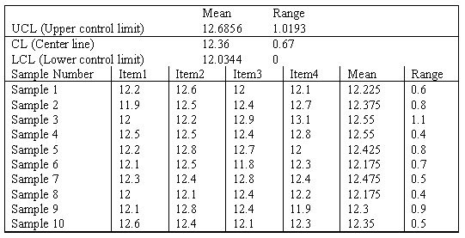
Answer: The sample size is 4; ten samples were taken. The mean of sample 8 is 12.175; the range of sample 10 is 0.5. This chart is built on 2-sigma limits, so the probability of a false signal is about 4.5%. The process is not in control–while all means are within limits, the range for sample 3 is too large. Investigate for assignable cause and eliminate that cause.
Diff: 3
Topic: Statistical Process Control (SPC)
AACSB: Analytic Skills
Objective: LO6-Supplement-4

108) Can "in control" and "capable" be shown on the same chart?
Answer: Only indirectly. The chart illustrating control plots the averages of small samples, while "Capability" is based on the dimensions of individual units. Figure S6.2 suggests that an overly wide range for sample means implies an overly large range for individual values as well.
Diff: 2
Topic: Statistical Process Control (SPC)
Objective: LO6-Supplement-1

109) What is the difference between natural and assignable causes of variation?
Answer: Natural variations are those variations that are inherent in the process and for which there is no identifiable cause. These variations fall in a natural pattern. Assignable causes are variations beyond those that can be expected to occur because of natural variation. These variations can be traced to a specific cause.
Diff: 2
Topic: Statistical Process Control (SPC)
Objective: LO6-Supplement-1
110) Why are x-bar and R-charts usually used hand in hand?
Answer: The ultimate goal of the x-bar and R-charts is to ascertain, by a sampling procedure, that the relevant parameter is kept within specific upper and lower bounds. The x-bar chart alone tells us only that the average values are within the appropriate limits. The combination of x-bar and the R-charts allows one to determine that both the average and the deviations are within the limits.
Diff: 2
Topic: Statistical Process Control (SPC)
Objective: LO6-Supplement-3

111) What does it mean for a process to be "capable"?
Answer: Process capability implies that the natural variation of the process must be small enough to produce products that meet the specifications or tolerances required.

Diff: 2
Topic: Process capability
Objective: LO6-Supplement-6

112) What is the difference between the process capability ratio Cp and the process capability index Cpk?
Answer: The Cp ratio does not consider how well the process average is centered on the target value. However, Cpk does consider how well the process is centered.
Diff: 2
Topic: Process capability
Objective: LO6-Supplement-6

113) A process is operating in such a manner that the mean of the process is exactly on the lower specification limit. What must be true about the two measures of capability for this process?
Answer: The Cp ratio does not consider how well the process average is centered on the target value; its value is unaffected by the setting for the process mean. However, Cpk does consider how well the process is centered; with x-bar on the LSL, the formula guarantees a Cpk of zero.
Diff: 2
Topic: Process capability
Objective: LO6-Supplement-6

114) What is acceptance sampling?
Answer: Acceptance sampling is a method of measuring random samples of lots or batches of products against predetermined standards.
Diff: 2
Topic: Acceptance sampling
Objective: LO6-Supplement-7
115) Why doesn't acceptance sampling remove all defects from a batch?
Answer: Acceptance sampling is a method of measuring random samples of lots or batches of products against predetermined standards. Acceptance sampling is not 100 percent inspection. Based on sampling results, the entire batch is either accepted or rejected. A batch may contain small numbers of defects and still meet the standard for acceptance.
Diff: 2
Topic: Acceptance sampling
Objective: LO6-Supplement-7

116) What is the purpose of the Operating Characteristics curve?
Answer: An OC curve plots the probability of acceptance against the percentage of defects in the lot. It therefore shows how well an acceptance sampling plan discriminates between good and bad lots.
Diff: 2
Topic: Acceptance sampling
Objective: LO6-Supplement-7

117) What is the AOQ of an acceptance sampling plan?
Answer: The AOQ is the average outgoing quality. It is the percent defective in an average lot of goods inspected through an acceptance sampling plan.
Diff: 2
Topic: Acceptance sampling
Objective: LO6-Supplement-7

118) Define consumer's risk. How does it relate to the errors of hypothesis testing? What is the symbol for its value?
Answer: The consumer's risk is the probability of accepting a bad lot. It is a Type II error; its value is beta.
Diff: 2
Topic: Acceptance sampling
Objective: LO6-Supplement-7

119) What four elements determine the value of average outgoing quality? Why does this curve rise, peak, and fall?
Answer: The four elements are the true percent defective of the lot, the probability of accepting the lot, the number of items in the lot, and the number of items in the sample. AOQ is near zero for very good output (which has few defects to find) and for very bad output (which often fails inspection and has its defects removed). AOQ has higher values for output of intermediate quality, for which the probability of rejection is not very high.
Diff: 2
Topic: Acceptance sampling
Objective: LO6-Supplement-7

120) What do the terms producer's risk and consumer's risk mean?
Answer: Producer's risk: the risk of rejecting a good lot; Consumer's risk: the risk of accepting a defective lot
Diff: 2
Topic: Acceptance sampling
Objective: LO6-Supplement-7
121) Pierre's Motorized Pirogues and Mudboats is setting up an acceptance sampling plan for the special air cleaners he manufactures for his boats. His specifications, and the resulting plan, are shown on the POM for Windows output below. In relatively plain English (someone else will translate for Pierre), explain exactly what he will do when performing the acceptance sampling procedure, and what actions he might take based on the results.

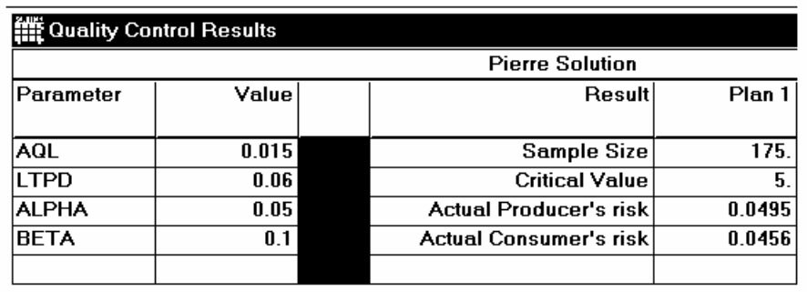
Answer: Pierre should select samples of size 175 from his lots of air cleaners. He should count the number of defects in each sample. If there are 4 or fewer defects, the lot passes inspection. If there are 5 or more defects, the lot fails inspection. Lots that fail can be handled several ways: they can be 100% inspected to remove defects; they can be sold at a discount; they can be destroyed; they can be sent back for rework, etc.
Diff: 2
Topic: Acceptance sampling
AACSB: Analytic Skills
Objective: LO6-Supplement-7

122) Pierre's Motorized Pirogues and Mudboats is setting up an acceptance sampling plan for the special air cleaners he manufactures for his boats. His specifications, and the resulting plan, are shown on the POM for Windows output below. Pierre is a bit confused. He mistakenly thinks that acceptance sampling will reject all bad lots and accept all good lots. Explain why this will not happen.

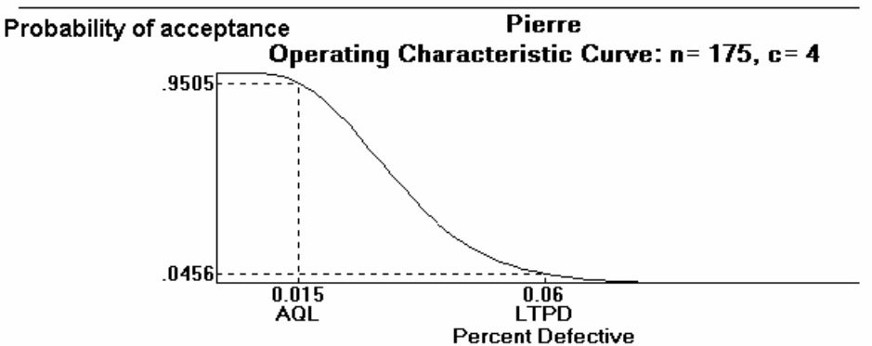
Answer: Acceptance sampling cannot discriminate perfectly between good and bad lots; this is illustrated by the OC curve that is not straight up and down. In this example, "good" lots will still be rejected almost 5% of the time. "Bad" lots will still be accepted almost 5% of the time.
Diff: 2
Topic: Acceptance sampling
Objective: LO6-Supplement-7
123) Pierre's Motorized Pirogues and Mudboats is setting up an acceptance sampling plan for the special air cleaners he manufactures for his boats. His specifications, and the resulting plan, are shown on the POM for Windows output below. Pierre wants acceptance sampling to remove ALL defects from his production of air cleaners. Explain carefully why this won't happen.

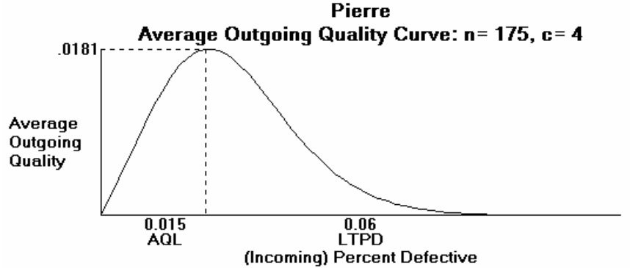
Answer: Acceptance sampling is not intended to remove all defects, nor will it. Consider a lot with a defect rate of 0.005 in this example. If the sample is representative, the lot will pass inspection--which means that no one will inspect the lot for defects. The defects that were present before sampling are still there. Generally, acceptance sampling passes some lots and rejects others. Defects can only be removed from those lots that fail inspection.
Diff: 2
Topic: Acceptance sampling
Objective: LO6-Supplement-7
124) A quality analyst wants to construct a sample mean chart for controlling a packaging process. He knows from past experience that the process standard deviation is two ounces. Each day last week, he randomly selected four packages and weighed each. The data from that activity appears below.
 | Weight
Day | Package 1 | Package 2 | Package 3 | Package 4
Monday | 23 | 22 | 23 | 24
Tuesday | 23 | 21 | 19 | 21
Wednesday | 20 | 19 | 20 | 21
Thursday | 18 | 19 | 20 | 19
Friday | 18 | 20 | 22 | 20

(a) Calculate all sample means and the mean of all sample means.
(b) Calculate upper and lower control limits that allow for natural variations.
(c) Is this process in control?
Answer:
(a) The five sample means are 23, 21, 20, 19, and 20. The mean of all sample means is 20.6
(b) UCL = 20.6 + 2.2/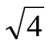= 22.6; LCL = 20.6 - 2.2/ = 18.6
(c) Sample 1 is above the UCL; all others are within limits. The process is out of control.
Diff: 2
Topic: Statistical Process Control (SPC)
AACSB: Analytic Skills
Objective: LO6-Supplement-3
125) A quality analyst wants to construct a sample mean chart for controlling a packaging process. He knows from past experience that when the process is operating as intended, packaging weight is normally distributed with a mean of twenty ounces, and a process standard deviation of two ounces. Each day last week, he randomly selected four packages and weighed each. The data from that activity appears below.
 | Weight
Day | Package 1 | Package 2 | Package 3 | Package 4
Monday | 23 | 22 | 23 | 24
Tuesday | 23 | 21 | 19 | 21
Wednesday | 20 | 19 | 20 | 21
Thursday | 18 | 19 | 20 | 19
Friday | 18 | 20 | 22 | 20

(a) If he sets an upper control limit of 21 and a lower control limit of 19 around the target value of twenty ounces, what is the probability of concluding that this process is out of control when it is actually in control?
(b) With the UCL and LCL of part a, what do you conclude about this process–is it in control?
Answer:
(a) These control limits are one standard error away from the centerline, and thus include 68.268 percent of the area under the normal distribution. There is therefore a 31.732 percent chance that, when the process is operating in control, a sample will indicate otherwise.
(b) The mean of sample 1 lies outside the control limits. All other points are on or within the limits. The process is not in control.
Diff: 2
Topic: Statistical Process Control (SPC)
AACSB: Analytic Skills
Objective: LO6-Supplement-3

126) An operator trainee is attempting to monitor a filling process that has an overall average of 705 cc. The average range is 17 cc. If you use a sample size of 6, what are the upper and lower control limits for the x-bar and R chart?
Answer: From table, A2 = 0.483, D4 = 2.004, D3 = 0

UCL = + A2 * 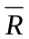 LCL = - A2 * UCLR = D4 *
= 705 + 0.483 x 17 = 705 - 0.483 * 17 = 2.004 * 17
= 713.211 = 696.789 = 34.068

LCLR = D3 *
= 0 * 17
= 0
Diff: 2
Topic: Statistical Process Control (SPC)
AACSB: Analytic Skills
Objective: LO6-Supplement-3
127) The defect rate for a product has historically been about 1.6%. What are the upper and lower control chart limits for a p-chart, if you wish to use a sample size of 100 and 3-sigma limits?
Answer:
UCLp = 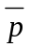+ 3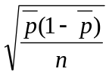 = 0.016 + 3 . 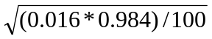 = .0536

UCLp = - 3 = 0.016 - 3 . = 0.0216, or zero

Diff: 2
Topic: Statistical Process Control (SPC)
AACSB: Analytic Skills
Objective: LO6-Supplement-5

128) A small, independent amusement park collects data on the number of cars with out-of-state license plates. The sample size is fixed at n=25 each day. Data from the previous 10 days indicate the following number of out-of-state license plates:
Day | Out-of-state Plates
1 | 6
2 | 4
3 | 5
4 | 7
5 | 8
6 | 3
7 | 4
8 | 5
9 | 3
10 | 11

(a) Calculate the overall proportion of "tourists" (cars with out-of-state plates) and the standard deviation of proportions.
(b) Using ± 3σ limits, calculate the LCL and UCL for these data.
(c) Is the process under control? Explain.
Answer: (a) p-bar is 56/250 = 0.224; the standard deviation of proportions is the square root of
.224 x .776 / 25 = 0.0834
(b) UCL = .224 + 3 x 0.834 = .4742; LCL = .224 -3 x .0834 which is negative, so the LCL = 0
(c) The largest percentage of tourists (day 10) is 11/25 = .44, which is still below the UCL. Thus, all the points are within the control limits, so the process is under control.
Diff: 2
Topic: Statistical Process Control (SPC)
AACSB: Analytic Skills
Objective: LO6-Supplement-5
129) Cartons of Plaster of Paris are supposed to weigh exactly 32 oz. Inspectors want to develop process control charts. They take ten samples of six boxes each and weigh them. Based on the following data, compute the lower and upper control limits and determine whether the process is in control.

Sample | Mean | Range
1 | 33.8 | 1.1
2 | 34.6 | 0.3
3 | 34.7 | 0.4
4 | 34.1 | 0.7
5 | 34.2 | 0.3
6 | 34.3 | 0.4
7 | 33.9 | 0.5
8 | 34.1 | 0.8
9 | 34.2 | 0.4
10 | 34.4 | 0.3

Answer: n = 6; overall mean = 34.23; 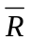 = 0.52.
Upper control limit | 34.48116 | 1.04208
Center line | 34.23 | 0.52
Lower control limit | 33.97884 | 0

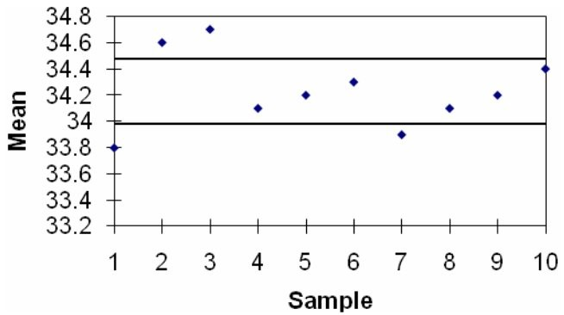
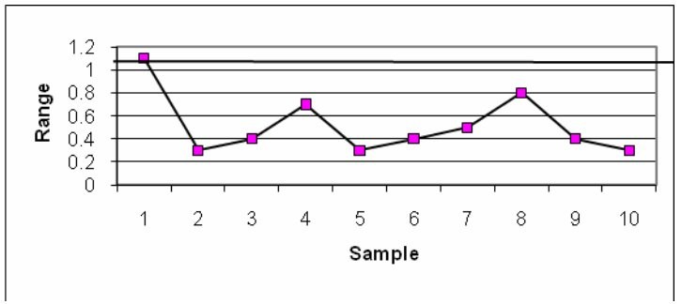
The mean values for samples 1, 2, 3, and 7 fall outside the control limits on the x-bar chart and sample 1 falls outside the upper limit on the R-chart. Therefore, the process is out of control.
Diff: 2
Topic: Statistical Process Control (SPC)
AACSB: Analytic Skills
Objective: LO6-Supplement-3
130) McDaniel Shipyards wants to develop control charts to assess the quality of its steel plate. They take ten sheets of 1" steel plate and compute the number of cosmetic flaws on each roll. Each sheet is 20' by 100'. Based on the following data, develop limits for the control chart, plot the control chart, and determine whether the process is in control.

Sheet | Number of flaws
1 | 1
2 | 1
3 | 2
4 | 0
5 | 1
6 | 5
7 | 0
8 | 2
9 | 0
10 | 2

Answer:
Total units sampled | 10
Total defects | 14
Defect rate, c-bar | 1.4
Standard deviation | 1.183216
z value | 3
Upper Control Limit | 4.949648
Center Line | 1.4
Lower Control Limit | 0

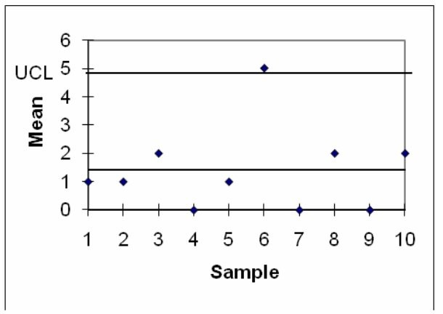
Sample six is above the control limits; therefore, the process is out of control.
Diff: 2
Topic: Statistical Process Control (SPC)
AACSB: Analytic Skills
Objective: LO6-Supplement-5
131) The mean and standard deviations for a process are μ= 90 and σ = 9. For the variable control chart, a sample size of 16 will be used. Calculate the standard deviation of the sampling distribution.
Answer: Sigma x-bar = 9/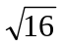= 2.25
Diff: 2
Topic: Statistical Process Control (SPC)
AACSB: Analytic Skills
Objective: LO6-Supplement-3

132) If μ = 9 ounces, σ = 0.5 ounces, and n = 9, calculate the 3-sigma control limits.
Answer: 8.50 to 9.50 ounces
Diff: 2
Topic: Statistical Process Control (SPC)
AACSB: Analytic Skills
Objective: LO6-Supplement-3

133) A hospital-billing auditor has been inspecting patient bills. While almost all bills contain some errors, the auditor is looking now for large errors (errors in excess of $250). Among the last 100 bills inspected, the defect rate has been 16%. Calculate the upper and lower limits for the billing process for 99.7% confidence.
Answer: 0.16 plus or minus 3 x 0.03667, or .050 to 0.270
Diff: 2
Topic: Statistical Process Control (SPC)
AACSB: Analytic Skills
Objective: LO6-Supplement-5

134) A local manufacturer supplies you with parts, and you would like to install a quality monitoring system at his factory for these parts. Historically, the defect rate for these parts has been 1.25 percent (You've observed this from your acceptance sampling procedures, which you would like to discontinue). Develop ± 3σ control limits for this process. Assume the sample size will be 200 items.
Answer: p-bar is 0.0125; the standard error of the proportion is 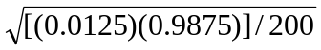= 0.00786.
The upper control limit is 0.0125 + 3 x 0.00786 = 0.03608; the lower control limit is
0.0125 — 3 x 0.00786 which is negative, so the LCL is 0.
Diff: 2
Topic: Statistical Process Control (SPC)
AACSB: Analytic Skills
Objective: LO6-Supplement-5

135) Repeated sampling of a certain process shows the average of all sample ranges to be 1.0 cm. The sample size has been constant at n = 5. What are the 3-sigma control limits for this R-chart?
Answer: zero to 2.115
Diff: 2
Topic: Statistical Process Control (SPC)
AACSB: Analytic Skills
Objective: LO6-Supplement-3
136) A woodworker is concerned about the quality of the finished appearance of her work. In sampling units of a split-willow hand-woven basket, she has found the following number of finish defects in ten units sampled: 4, 0, 3, 1, 2, 0, 1, 2, 0, 2.

a. Calculate the average number of defects per basket
b. If 3-sigma control limits are used, calculate the lower control limit, centerline, and upper control limit.
Answer: (a) 1.5; (b) 0, 1.5, and 5.2.
Diff: 2
Topic: Statistical Process Control (SPC)
AACSB: Analytic Skills
Objective: LO6-Supplement-5

137) The width of a bronze bar is intended to be one-eighth of an inch (0.125 inches). Inspection samples contain five bars each. The average range of these samples is 0.01 inches. What are the upper and lower control limits for the x-bar and R-chart for this process, using 3-sigma limits?
Answer: X-bar: LCL = .119; UCL =.131. R: LCL = 0.0; UCL =.021
Diff: 2
Topic: Statistical Process Control (SPC)
AACSB: Analytic Skills
Objective: LO6-Supplement-3

138) A part that connects two levels should have a distance between the two holes of 4". It has been determined that x-bar and R-charts should be set up to determine if the process is in statistical control. The following ten samples of size four were collected. Calculate the control limits, plot the control charts, and determine if the process is in control.

 | Mean | Range
Sample 1 | 4.01 | 0.04
Sample 2 | 3.98 | 0.06
Sample 3 | 4.00 | 0.02
Sample 4 | 3.99 | 0.05
Sample 5 | 4.03 | 0.06
Sample 6 | 3.97 | 0.02
Sample 7 | 4.02 | 0.02
Sample 8 | 3.99 | 0.04
Sample 9 | 3.98 | 0.05
Sample 10 | 4.01 | 0.06

Answer:
 | X-bar | Range
x-doublebar value | 3.998
R bar | 0.042
Upper control limit | 4.029 | 0.096
Center line | 3.998 | 0.042
Lower control limit | 3.967 | 0

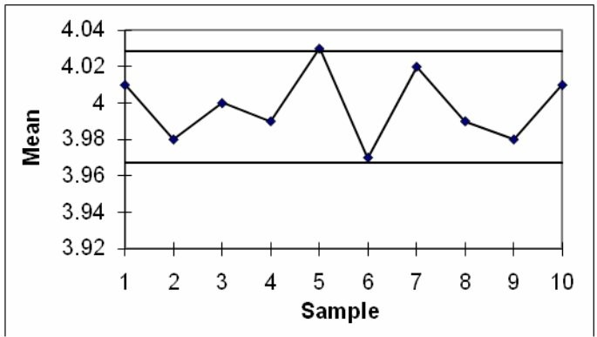
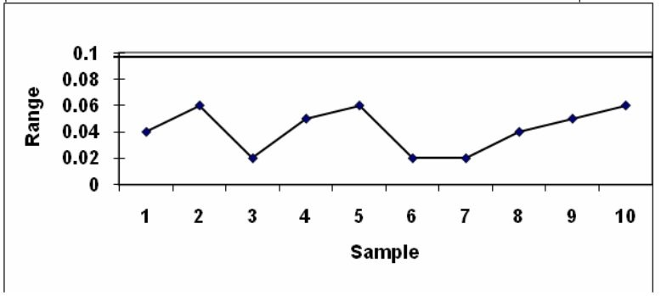
The process is out of control because of sample 5 on the x-bar chart.
Diff: 2
Topic: Statistical Process Control (SPC)
AACSB: Analytic Skills
Objective: LO6-Supplement-3

139) Ten samples of size four were taken from a process, and their weights measured. The sample averages and sample ranges are in the following table. Construct and plot an x-bar and R-chart using this data. Is the process in control?

Sample | Mean | Range
1 | 20.01 | 0.45
2 | 19.98 | 0.67
3 | 20.25 | 0.30
4 | 19.90 | 0.30
5 | 20.35 | 0.36
6 | 19.23 | 0.49
7 | 20.01 | 0.53
8 | 19.98 | 0.40
9 | 20.56 | 0.95
10 | 19.97 | 0.79

Answer:
 | X-bar | Range
x-doublebar value | 20.024
R bar | 0.524
Upper control limit | 20.406 | 1.196
Center line | 20.024 | 0.524
Lower control limit | 19.642 | 0

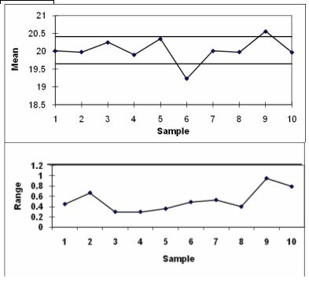
The x-bar chart is out of control because samples 6 and 9 are outside of the control limit, and therefore the process is out of control.
Diff: 2
Topic: Statistical Process Control (SPC)
AACSB: Analytic Skills
Objective: LO6-Supplement-3

140) arry's boat shop wants to monitor the number of blemishes in the paint of each boat. Construct a 3-sigma c-chart to determine if their paint process is in control using the following data.

Sample Number | Number of  Defects
1 | 3
2 | 4
3 | 2
4 | 1
5 | 3
6 | 2
7 | 1
8 | 4
9 | 2
10 | 3

Answer: Total units sampled | 10
Total defects | 25
Defect rate, c-bar | 2.5
Standard deviation | 1.581
z value | 3
Upper Control Limit | 7.243
Center Line | 2.5
Lower Control Limit | 0

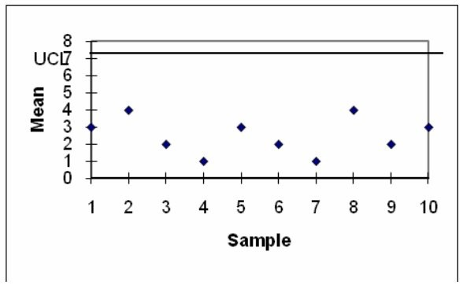
The process is in control.
Diff: 2
Topic: Statistical Process Control (SPC)
AACSB: Analytic Skills
Objective: LO6-Supplement-4

141) The specifications for a manifold gasket that installs between two engine parts calls for a thickness of 2.500 mm ± .020 mm. The standard deviation of the process is estimated to be 0.004 mm. What are the upper and lower specification limits for this product? The process is currently operating at a mean thickness of 2.50 mm. (a) What is the Cp for this process? (b) About what percent of all units of this liner will meet specifications? Does this meet the technical definition of Six Sigma?
Answer: (a) LSL = 2.48 mm, USL = 2.52 mm. Cp = (2.52 — 2.48)/(6*0.004) = 1.67. (b) Each specification limit lies 5 standard deviations from the centerline, so practically 100 percent of units will meet specifications. However, this percentage is not quite as high as Six Sigma would call for.
Diff: 2
Topic: Process capability
AACSB: Analytic Skills
Objective: LO6-Supplement-6
142) The specifications for a manifold gasket that installs between two engine parts calls for a thickness of 2.500 mm ± .020 mm. The standard deviation of the process is estimated to be 0.004 mm. What are the upper and lower specification limits for this product? The process is currently operating at a mean thickness of 2.50 mm. (a) What is the Cp for this process? (b) The purchaser of these parts requires a capability index of 1.50. Is this process capable? Is this process good enough for the supplier? (c) If the process mean were to drift from its setting of 2.500 mm to a new mean of 2.497, would the process still be good enough for the supplier's needs?
Answer: (a) LSL = 2.48 mm, USL = 2.52 mm. Cp = (2.52 — 2.48)/(6*0.004) = 1.67. (b) Yes to both parts of the question. (c) The Cpk index is now relevant, and its value is the lesser of 1.917 and 1.417. The process is still capable, but not to the supplier's needs.
Diff: 2
Topic: Process capability
AACSB: Analytic Skills
Objective: LO6-Supplement-6

143) The specification for a plastic liner for concrete highway projects calls for a thickness of 6.0 mm ± 0.1 mm. The standard deviation of the process is estimated to be 0.02 mm. What are the upper and lower specification limits for this product? The process is known to operate at a mean thickness of 6.03 mm. What is the Cp and Cpk for this process? About what percent of all units of this liner will meet specifications?
Answer: LSL = 5.9 mm, USL = 6.1 mm. Cp is (6.1-5.9)/6(.02) = 1.67. Cpk is the lesser of (6.1-6.03)/(3*0.02) = 1.17 and (6.03 - 5.9)/(3*0.02) = 2.17; therefore, 1.17. The upper specification limit lies about 3 standard deviations from the centerline, and the lower specification limit is further away, so practically all units will meet specifications.
Diff: 2
Topic: Process capability
AACSB: Analytic Skills
Objective: LO6-Supplement-6

144) The specification for a plastic handle calls for a length of 6.0 inches ± .2 inches. The standard deviation of the process is estimated to be 0.05 inches. What are the upper and lower specification limits for this product? The process is known to operate at a mean thickness of 6.1 inches. What is the Cp and Cpk for this process? Is this process capable of producing the desired part?
Answer: LSL = 5.8 inches, USL = 6.2 inches. Cp is (6.2-5.8)/6(.05) = 1.33. Cpk is the lesser of (6.2-6.1)/(3*0.05) = .67 and (6.1 - 5.8)/(3*0.02) = 2.00; therefore, .67. The process is capable based upon the Cp. However, the process is not centered (based upon its Cpk) and based upon its current center is not producing parts that are of an acceptable quality.
Diff: 2
Topic: Process capability
AACSB: Analytic Skills
Objective: LO6-Supplement-6

145) In the table below are selected values for the OC curve for the acceptance sampling plan n=210, c=6. Upon failed inspection, defective items are replaced. Calculate the AOQ for each data point. (You may assume that the population is much larger than the sample.) Plot the AOQ curve. At approximately what population defective rate is the AOQ at its worst? Explain how this happens. How well does this plan meet the specifications of AQL=0.015, α=0.05; LTPD=0.05, β=0.10? Discuss.

Population percent defective | Probability of acceptance
0.00 | 1.00000
0.01 | 0.99408
0.02 | 0.86650
0.03 | 0.55623
0.04 | 0.26516
0.05 | 0.10056
0.06 | 0.03217
0.07 | 0.00905
0.08 | 0.00231
0.09 | 0.00054
0.10 | 0.00012
Answer: The plan meets the α and the β specification fairly well.

Population percent defective | Probability of acceptance | AOQ
0.00 | 1.000 | 0.0000
0.01 | 0.994 | 0.0099
0.015 | 0.958 | 0.0144 | At AQL
0.02 | 0.867 | 0.0173 | maximum
0.03 | 0.558 | 0.0167
0.04 | 0.267 | 0.0107
0.05 | 0.102 | 0.0051 | At LTPD
0.06 | 0.033 | 0.0020
0.07 | 0.009 | 0.0006
0.08 | 0.002 | 0.0002
0.09 | 0.001 | 0.0001

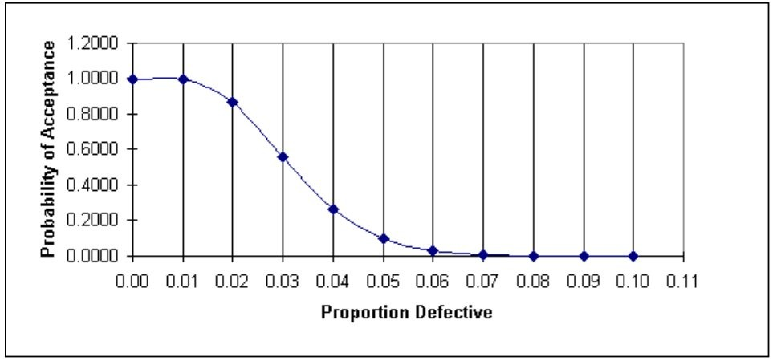
Diff: 2
Topic: Acceptance sampling
AACSB: Analytic Skills
Objective: LO6-Supplement-8
146) In the table below are selected values for the OC curve associated with the acceptance sampling plan n=50, c=1. (Watch out--the points are not evenly spaced.) Assume that upon failed inspection, defective items are replaced. Calculate the AOQ for each data point. (You may assume that the population is much larger than the sample.) Plot the AOQ curve. At approximately what population defective rate is the AOQ at its worst? Explain how this happens. How well does this plan meet the specifications of AQL=0.0050, α =0.05; LTPD=0.05, β =0.10? Discuss.

Population percent defective | Probability of acceptance
0.005 | 0.97387
0.01 | 0.91056
0.02 | 0.73577
0.03 | 0.55528
0.04 | 0.40048
0.05 | 0.27943
0.06 | 0.19000
0.08 | 0.08271

Answer: This plan does not meet the specification very well. At .005 defective, the probability of acceptance is not 95% but over 97. At 0.05 defective, the acceptance rate is not 5% but 28.

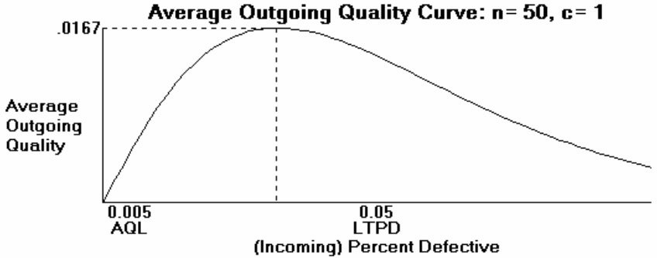

Population percent defective | Probability of acceptance | AOQ
0.005 | 0.97387 | 0.004869 | at AQL
0.01 | 0.91056 | 0.009106
0.02 | 0.73577 | 0.014715
0.03 | 0.55528 | 0.016658 | maximum
0.04 | 0.40048 | 0.016019
0.05 | 0.27943 | 0.013972 | at LTPD
0.06 | 0.19000 | 0.0114
0.08 | 0.08271 | 0.006617

Diff: 2
Topic: Acceptance sampling
AACSB: Analytic Skills
Objective: LO6-Supplement-7, LO6-Supplement-8
147) A bank's manager has videotaped 20 different teller transactions to observe the number of mistakes being made. Ten transactions had no mistakes, five had one mistake and five had two mistakes. Compute proper control limits at the 90% confidence level.
Answer: A c-chart should be used, and from Table S6.2, the z-value = 1.65.
The mean c-bar = [10(0) + 5(1) + 5(2)]/20 = 0.75.
UCLc = 0.75 + 1.65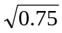 = 2.18
LCLc = 0.75 - 1.65 = -0.68 (or 0)
Diff: 2
Topic: Statistical Process Control (SPC)
AACSB: Analytic Skills
Objective: LO6-Supplement-5

148) A department chair wants to monitor the percentage of failing students in classes in her department. Each class had an enrollment of 50 students last spring. The number of failing students in the 10 classes offered that term were 1, 4, 2, 0, 0, 0, 0, 0, 0, and 3, respectively. Compute the control limits for a p-chart at the 95% confidence level. Is the process in control?
Answer: From Table S6.2, the z-value = 1.96.
The mean p-bar = [1+4+2+0+0+0+0+0+0+3]/(50×10) = 0.02.

σp = 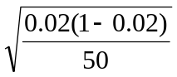 0.0198

UCLp = 0.02 + 1.96(.0198) = 0.0589
LCLp = 0.02 - 1.96(.0198) = -0.0189 (or 0)
Since the percent defects in classes 2 and 10 both exceeded 5.89%, the percentage of failing students is not in statistical control. The department chair should investigate.
Diff: 2
Topic: Statistical Process Control (SPC)
AACSB: Analytic Skills
Objective: LO6-Supplement-5

149) A city police chief decides to do an annual review of the police department by checking the number of monthly complaints. If the total number of complaints in each of the 12 months were 15, 18, 13, 12, 16, 20, 5, 10, 9, 11, 8, and 3 and the police chief wants a 90% confidence level, are the complaints in control?
Answer: From Table S6.2 z=1.65
c-bar = (15+18+13+12+16+20+5+10+9+11+8+3)/12 = 11.67 complaints
UCL= 11.67+1.65 (v 11.67) =17.307 complaints
LCL= 11.67 — 1.65 (v11.67) = 6.033 complaints
Since the points 18 and 20 fall above the UCL and points 5 and 3 fall below the LCL, the complaints are not in control.
Diff: 2
Topic: Statistical Process Control (SPC)
AACSB: Analytic Skills
Objective: LO6-Supplement-5
150) A consultant has been brought in to a manufacturing plant to help apply six sigma principles. Her first task is to work on the production of rubber balls. The upper and lower spec limits are 21 and 19 cm respectively. The consultant takes ten samples of size five and computes the sample standard deviation to be .7 cm and the sample mean to be 19.89 cm. Compute Cp and Cpk for the process. Give the consultant advice on what to do with the process based on your findings.
Answer: Cp = (21-19)/(6*.7) =.476
Cpk = min ( (21-19.89)/ (3*.7), (19.89-19)/(3*.7)) = .424
The very low capability metrics mean the process is not controllable within three-sigma limits. The consultant should therefore focus on assignable variation.
Diff: 2
Topic: Process capability
AACSB: Analytic Skills
Objective: LO6-Supplement-6

151) A car mechanic is thinking of guaranteeing customers that an oil change will take no more than 15 minutes with a 99.73% confidence level. He takes a few samples of size 5 and finds the process mean to be 13 minutes with a standard deviation of .2 minutes and average sample range of 1.2 minutes. Find the A2, D4, and D3 values and use them to compute the upper and lower limits for an x-bar chart. Use the upper limit to determine if the mechanic can offer a 15 minute guarantee. Assume the mechanic plots the samples on the x-bar control chart and finds the process is in control, is there anything else the mechanic is missing to ensure the process is in control?
Answer: From Table S6.1
A2 = .577
D4 = 2.115
D3 = 0

UCL = 13 + .577 (1.2) = 13.69 minutes
LCL = 13 - .577(1.2) = 12.308 minutes
The upper limit is less than 15, so the mechanic can offer the guarantee and be on time over 99.73% of the time. However, the mechanic forgot to calculate an R-chart to check his samples to ensure the process is in control.
Diff: 2
Topic: Statistical Process Control (SPC)
AACSB: Analytic Skills
Objective: LO6-Supplement-3
152) At your first job out of college you have been assigned to the production of bottled 20 oz. soda.
The process has upper and lower limits of 20.5 and 19.5 oz, respectively, with a mean of 19.8 oz
and standard deviation of .3 oz. Your manager has requested the process produce no more than 3.4
defects per 1 million bottles produced. Calculate Cpk and then determine if the process is capable
or if you should be looking for assignable variation.
Answer: Cpk = minimum ( (20.5-19.8)/(3*.3),(19.8-19.5)/(3*.3)) = .333 oz
The process is not capable because Cpk is less than the 2.0 required for under 3.4 defects per million. Thus you should focus on eliminating assignable variation from the process, working to both center the mean and reduce the average sample range.
Diff: 2
Topic: Process capability
AACSB: Analytic Skills
Objective: LO6-Supplement-6

153) A retail store manager is trying to improve and control the rate at which cashiers sign customers up for store credit cards. Suppose that the manager wants the maximum standard deviation of the sampling distribution to be 5% and he cannot estimate p-bar. How many observations per sample would this require?
Answer: Maximum standard deviation occurs when p-bar = .5. Using the equation for sigma-p to get
.05=sqrt(.5(1-.5)/n). Solving for n gives n=100 observations per sample required.
Diff: 3
Topic: Statistical Process Control (SPC)
AACSB: Analytic Skillsx
Objective: LO6-Supplement-5

154) A retail store manager is trying to improve and control the rate at which cashiers sign customers up
for store credit cards. Suppose the manager takes 10 samples, each with 100 observations. P-bar
is found to be .05, and the manager does not want a lower limit below .0064. What z-value would
this imply, and how confident can he be that the true lower limit is greater than or equal to .0064?
Answer: Sigma-p = sqrt ( .05*(1-.05)/100) = .0217945. Using the equation that LCL=p-bar-z*sigma-p gives .0064=.05-z*(.0217945). Solving gives z=2. Using table S6.2 shows that for z=2 the manager can be 95.45% confident.
Diff: 2
Topic: Statistical Process Control (SPC)
AACSB: Analytic Skills
Objective: LO6-Supplement-5
155) A retail store manager is trying to improve and control the rate at which cashiers sign customers up
for store credit cards. After posting a p-chart of the store's credit card sign-ups the manager takes
new samples of size 50 three weeks later. He finds that each sample of 50 contained 5 credit card
signups on average. Find p-bar and 99.73% control limits.
Answer: P-bar = 5/50 = .1 or 10%. Sigma-p = sqrt(.1(1-.1)/50) = .042426. z=3 for the given confidence level. Using the equations for control limits gives
UCL= .1+3(.042426) = .22728
LCL= .1 — 3(.042426) = -.02728 and since a control limit cannot be negative round up to 0.
Diff: 2
Topic: Statistical Process Control (SPC)
AACSB: Analytic Skills
Objective: LO6-Supplement-5

